**Secrets:**

* Secrets are stores in ETCD in master.
* Secret data can not be more than 1 MB.

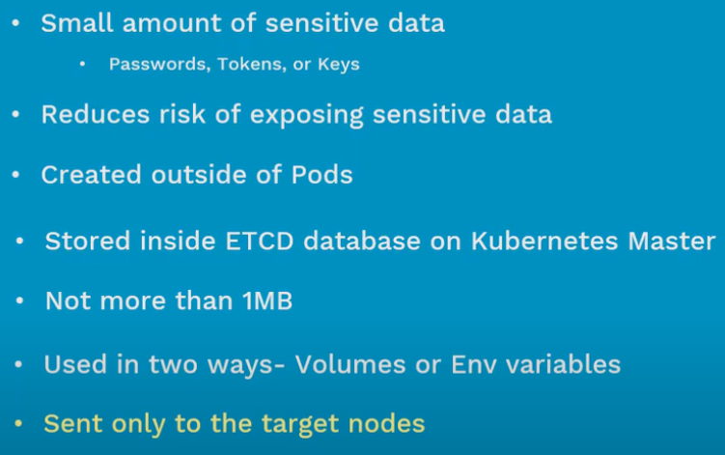

**Creating secret:**

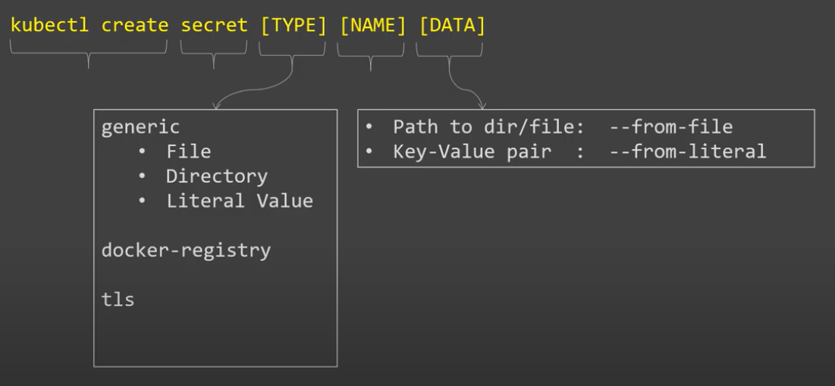

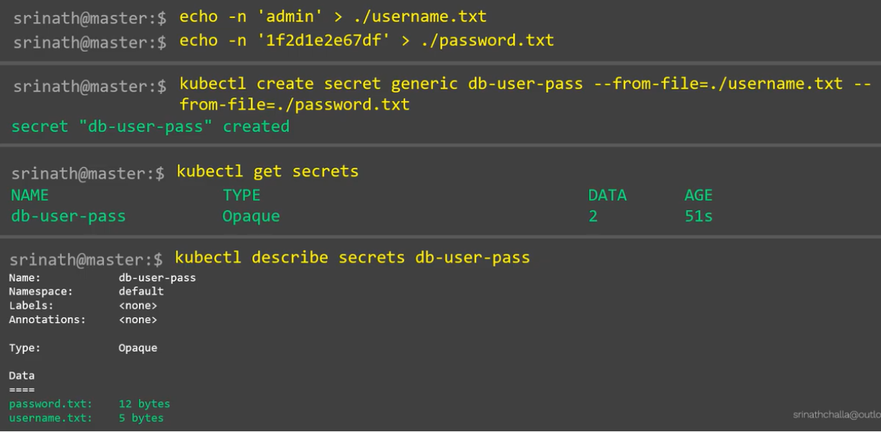

**Creating via yaml file:**

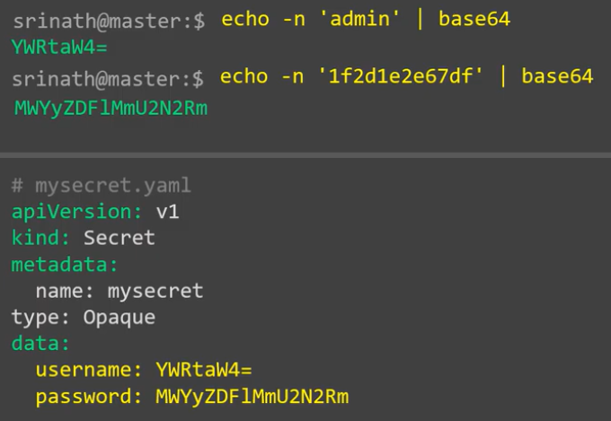

* Secrets will not display the data as it is when we see the yaml file in cluster. It encodes the data.

**Pod manifest file:**

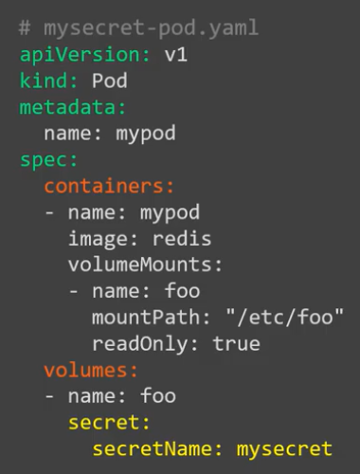

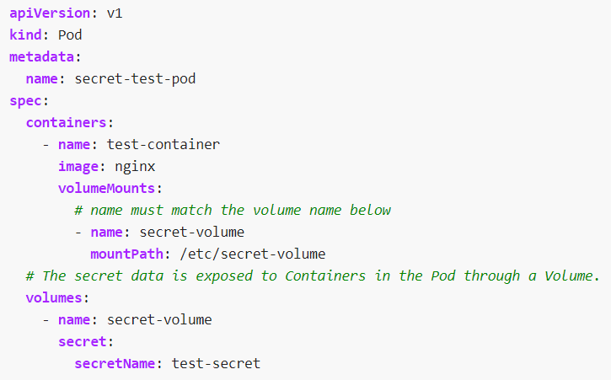

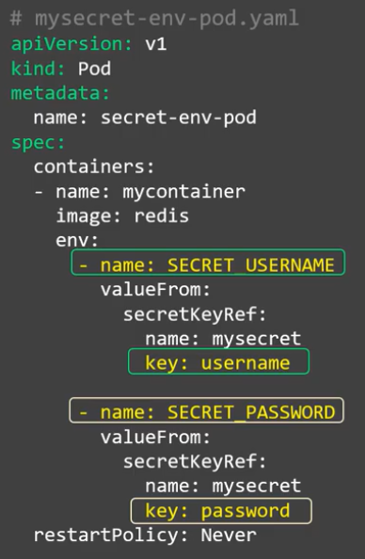

* Secret reference in pod with multiple values as below.

